* Starting game, first player can choose to be X or O.

Lab 2 TicTacToe Test Output

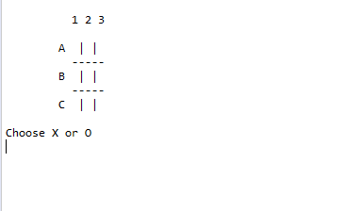

* Player X winning the game:

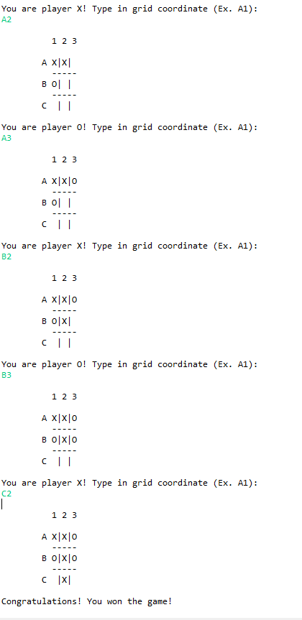

* Player O winning the game:

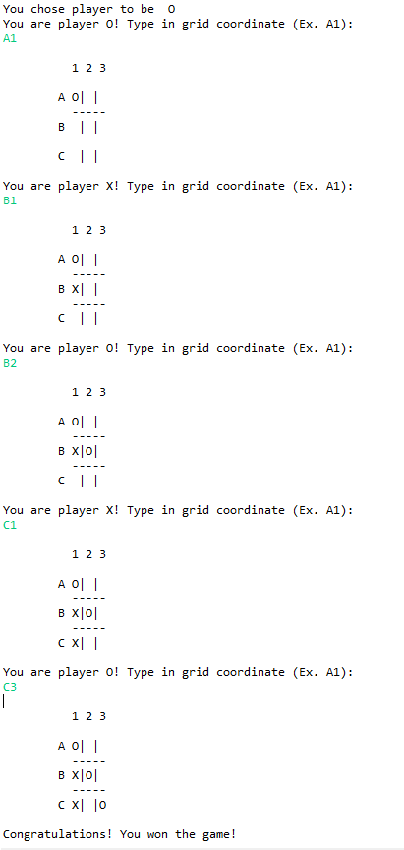

* Player X and O going into Stalemate.

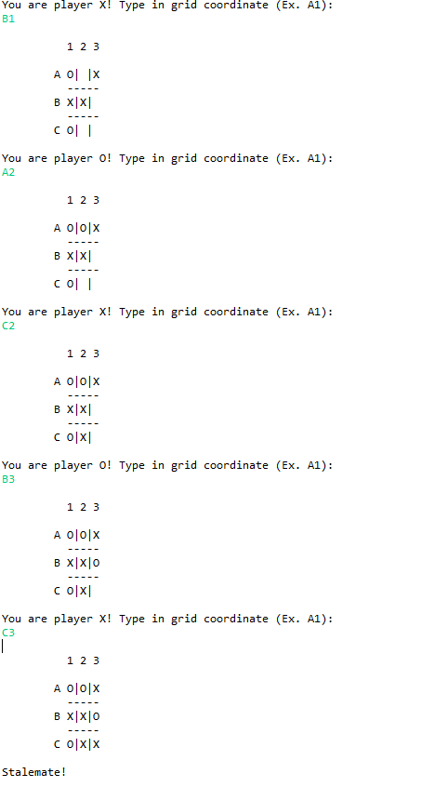

* User entering in invalid input

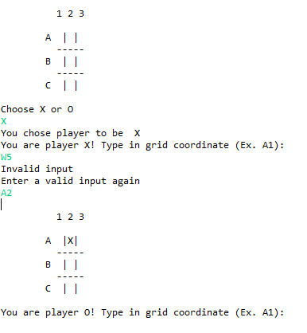

* Player O making an illegal move

